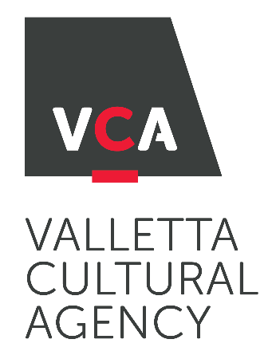
;

InnovAiR 2021
OPEN CALL FOR REMOTE ARTIST IN RESIDENCE

APPLICATION FORM
1. DETAILS OF THE APPLICANT/S
Should the applicants be individual artists or a group (2 or more artists) working together please include details of both applicants;
Name:
Address:
ID Card Number:
Mobile Number:
Email Address:
Discipline/s

2. PROJECT DESCRIPTION
Please describe the project idea you would like to present and explain how it is

- Innovative
- Virtually Engaging and collaborative
- Virtually Interactive and participatory

*Not more than 300 words
2a) Indicate Project Discipline/s

2b) Indicate the residency goals
*Not more than 100 words

2c) Indicate the format and description of the final digital public sharing (e.g. presentation, lecture, performance, screening, digital booklet, short tutorial, etc.)
*Not more than 200 words

2d) Indicate the work to be created during the residency
*Not more than 200 words

2e) Indicate preferred length and dates for the residency period

DURATION | DATES
1 week
2 weeks
3 weeks

3. NAME(s) OF THE FUNDING PARTNER(s).
Kindly include details if applicable

CHECKLIST: Have you attached…?
Please tick as applicable.
 | Yes | No
Copy of Artist’s ID Card or passport;
Artist professional CV and a short Bio;
CV of the Lead Artist
A portfolio of related works (Visual artists: images or video links; Performing artists: a synopsis of previous works, video links and reviews; Literature: a list of publications and professional acknowledgements);
Timeline of Actions
any other document supporting the artistic proposal
Do you have a VAT number?

Name of Artist/s: _______________________

Signature of Artist/s: _______________________

_____________________________________________________________

By signing this declaration, I confirm that I have read the gguidelines and that I accept the conditions and process as stipulated in this same document.

